PROG1245

Web Foundations Individual Major Assignment #2 - 10% **Due Date: Jan 12, 2018 pm**

**ASSIGNMENT:**

This assignment will allow you to experience what it is like to develop a complete website from scratch. To do this you will create a fan site of one your favourite subjects; this can be a Movie, TV show, Book, Band, Video Game or anything that you have a great interest in.

You may continue to develop and enhance your work from Assignment 1, or start a new project from scratch.

Instructions on specific requirements are as follows;

**General Instructions**

1. 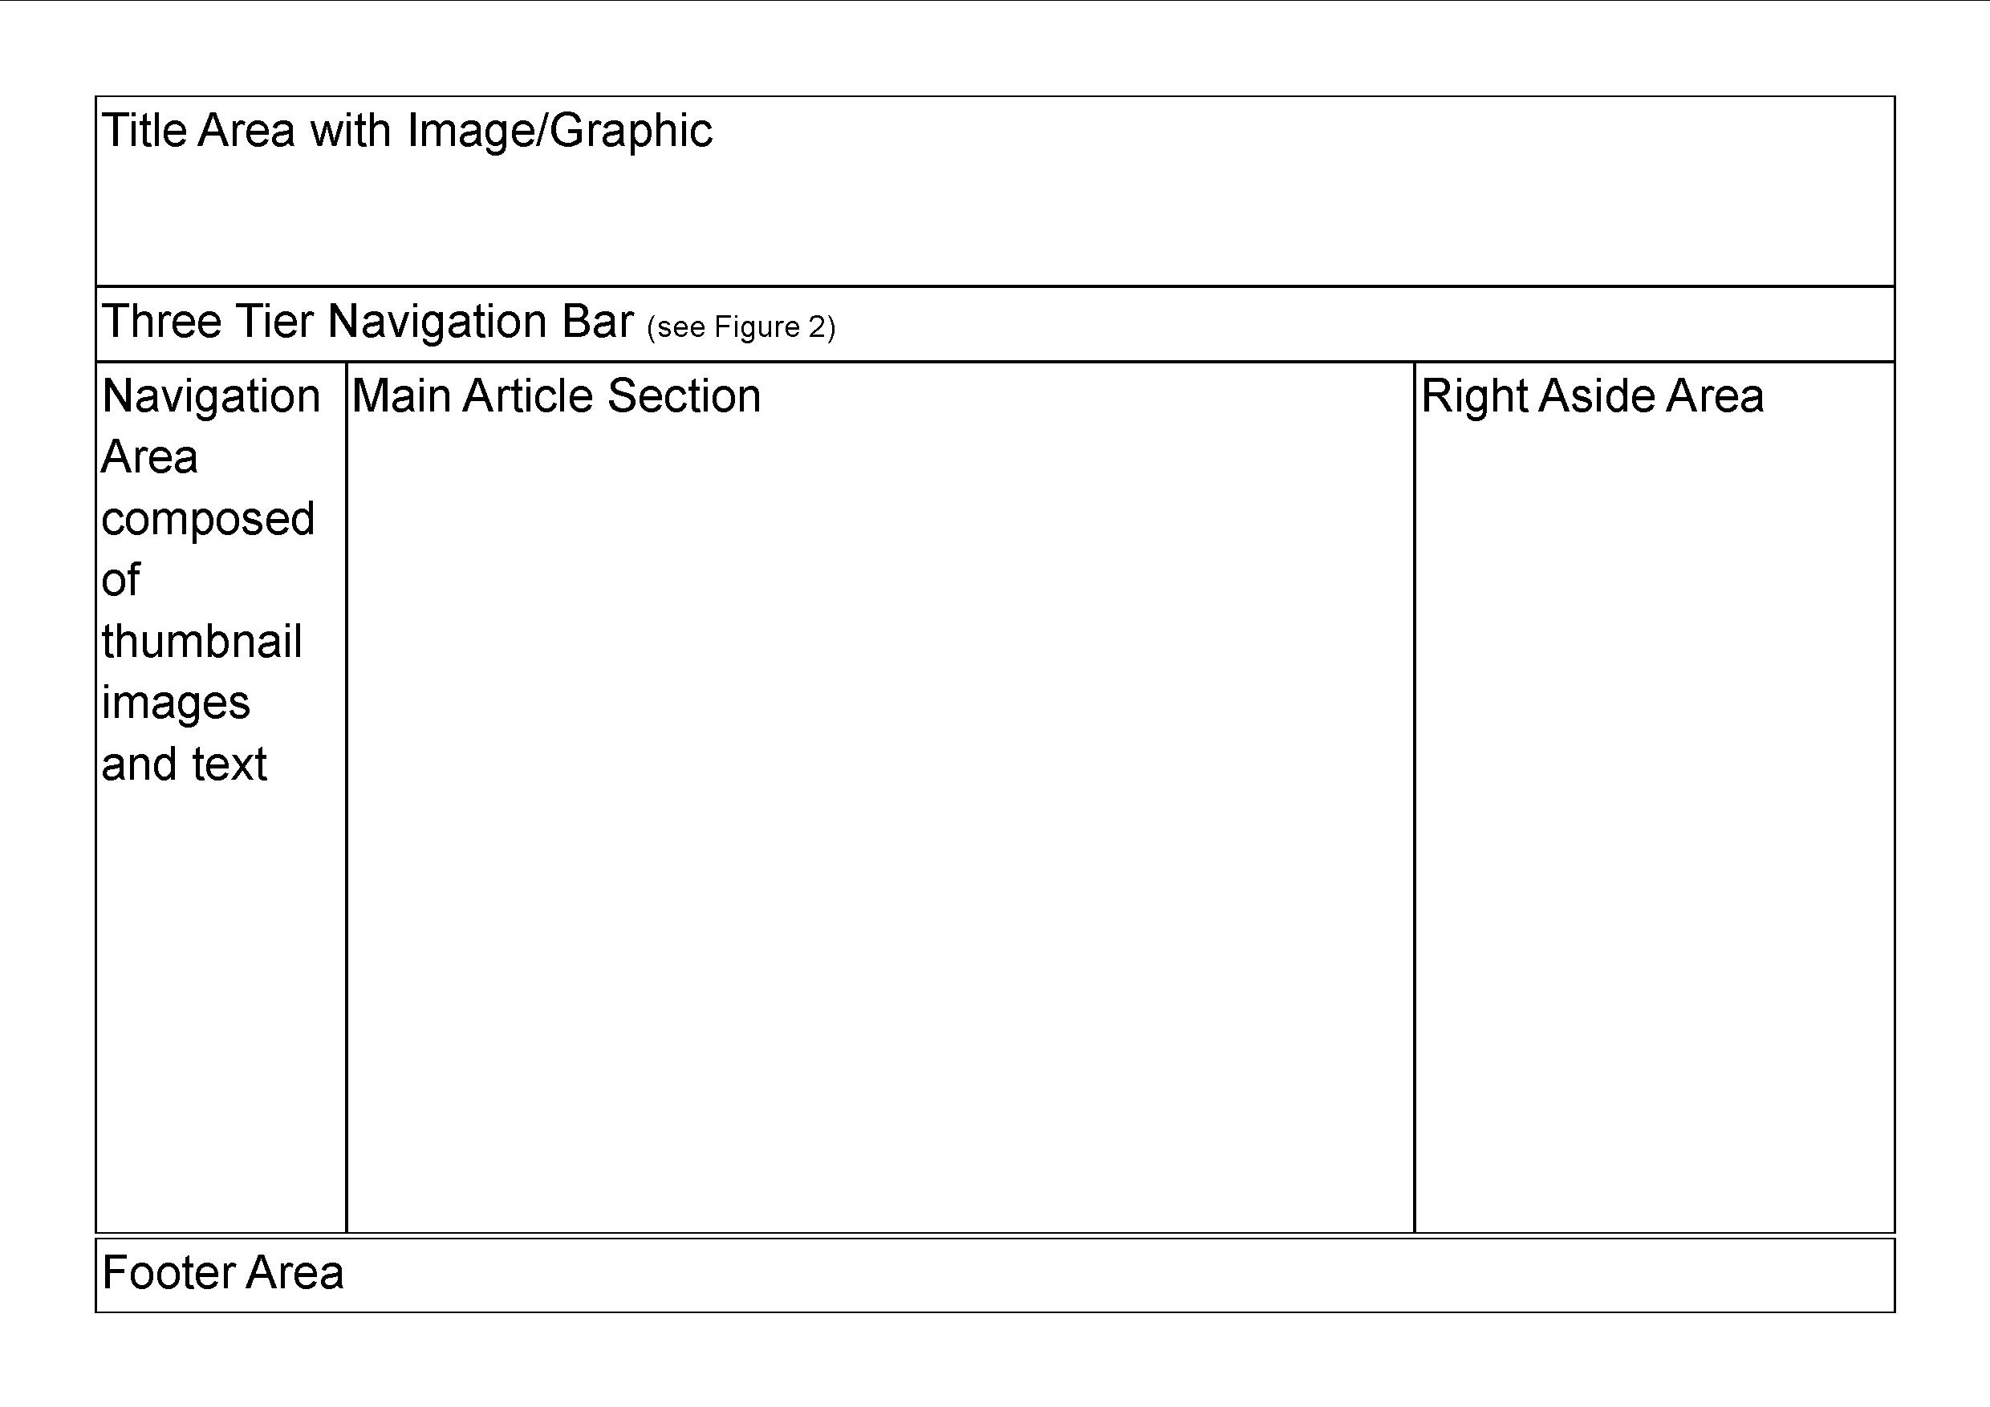Build a template using the design pattern as illustrated in Figure 1: Sample Web Page Format. This will be used for all pages.
2. Use well-formed HTML5 and CSS3 structure including use of semantic elements.
3. Keep in mind AODA considerations when developing your template.
4. Use a logical folder structure to organize you site;
   1. styles
   2. pages/subpages
   3. images
   4. thumbnails
   5. media

Figure : Sample Web Page Format

* 1. scripts (if any)
  2. etc.

1. 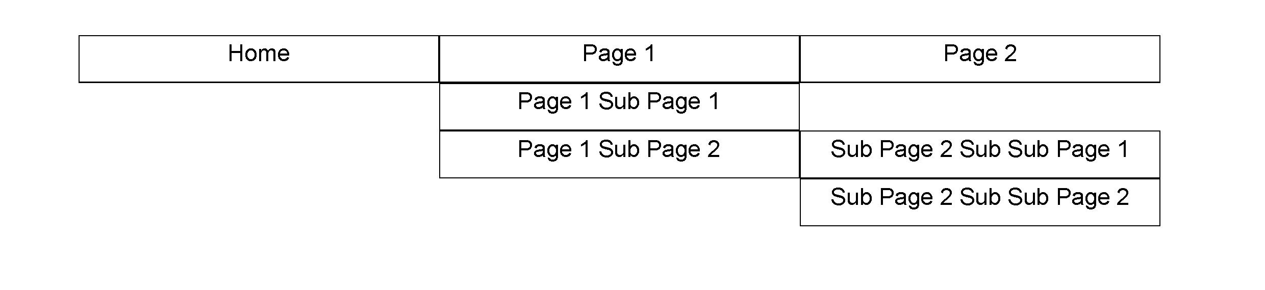The template will contain at tiered navigation bar with a minimum of two and maximum of three levels. For example, one of the top tier menu items will have a sub menu, and one of these sub menus may have a sub-sub menu. A responsive site might only contain two levels of navigation to accommodate small devices.
2. Each page will use the same tab/page favicon. Each page should have a separate title.
3. Each page will have a footer. The footer will be consistent throughout this site as defined in the template.
4. There will be a **main.css** file that will control elements that are common throughout the site, i.e. navigation bar, navigation area, article area, etc
   1. Each page will have consistent colouring throughout defined in the **main.css**.
   2. Each page is to have consistent font family styling on each page defined in the **main.css**.
   3. Use various CSS controls such as hover, focus, etc to control the appearance of the navigation bar so that the navigation items are identifiable when being manipulated.
5. Each page will have its own CSS file, specific to unique items within that page.
   1. For instance, the **image.css** will contain CSS to manipulate images within the **image.html** page.
   2. For instance, the **table.css** will contain CSS to manipulate tables within the **table.html** page.
6. The Navigation Area composed of Thumbnail images will consist of the following;
   1. The top thumbnail image will link to the home page.
   2. Subsequent thumbnail images will provide links for pages that are below the home page, i.e. these would match the top tier of your navigation bar.
   3. Each of these thumbnail images will contain a text caption describing the thumbnail.
   4. This thumbnail image navigation area will be the same throughout the site.
   5. The Thumbnail Navigation Area should be distinguishable from the other areas of your site by colour or border or both.
7. Any content images and videos should have a border placed around them.
8. If you wish you may incorporate JavaScript, however this is not a graded item.
9. The completed Assignment will be in a Zipped folder and submitted to the appropriate folder in D2L.

Note: The file should be named <your-first-name>-<your-last-name>-a2.zip

**Home Page (Index.html) - This will be based on your Template and is a mandatory page.**

1. Page will be built using the provided general Instructions in mind.
2. Please create an **index.css** file for formatting and decorating specific to your **index.html** file.
3. The Title Area or banner will incorporate the title of your site. It will contain a relevant graphic or image within the area, this can be left or right justified or both.
4. Use an article to describe what the site is about.
5. The right aside area will be used to provide additional information relevant to your site, i.e. a fun facts sections or perhaps links to other sites that are similar to yours.

**Construct any two of the following pages as part of your website. Identify these appropriately on your Navigation Bar, and in the Thumbnail Navigation**

**Image Page (images.html)**

1. Page will be built using the provided general instructions in mind.
2. Please create an **image.css** for formatting and decorating specific to your **image.html** file.
3. The Title Area will incorporate the title of your site. It will contain a relevant graphic or image within the area, this can be left or right justified or both. It will also contain a subtitle specific to this page.
4. This page will consist of images in tribute to your topic.
   1. This will be in the article section of your site.
   2. They will be in a tiled area format with each area being a consistent size.
   3. Each image does not need to be the same size, actually a variety of sizes would add interest to the site
   4. They will all be bordered.
   5. They will all have some space around them, i.e. they should not be above each other.
   6. Each image should contain a caption giving a brief description of the picture.
   7. When they are moused over they expand to a size that is easily visible.
5. The right aside area can used for your choice, i.e. a descriptor about the images, links to other similar images, etc.
6. All other areas within the page should be built similar to the home page.

**HINT:** Consider using lists to accomplish the above.

**Video Page (video.html)**

1. Page will be built using the provided general instructions in mind.
2. Please create a **video.css** for formatting and decorating specific to your **video.html** file.
3. The Title Area will incorporate the title of your site. It will contain a relevant graphic or image within the area, this can be left or right justified or both. It will also contain a subtitle specific to this page.
4. The article section will contain at least one video about your topic
   1. The video(s) should be framed with a border.
   2. Include a caption for your video(s)
5. The right aside area should be used to describe the video, links to other similar videos, consider linking to YouTube video(s) relevant to your topic, etc.
6. All other areas within the page should be built similar to the home page.

**Table Page (table.html)**

1. Page will be built using the provided general instructions in mind.
2. Please create a **table.css** for formatting and decorating specific to your **table.html** file.
3. The Title Area will incorporate the title of your site. It will contain a relevant graphic or image within the area, this can be left or right justified or both. It will also contain a subtitle specific to this page.
4. The article section will contain a table providing statistical information relevant to your topic.
   1. This content must be formatted using CSS.
   2. An example would be if the site was a tribute to a hockey player, the table would contain statistics for the hockey player’s past several seasons such as year, goals, assists, penalties, games played etc.
5. All other areas within the page should be built similar to the home page.

**Feedback Page (feedback.html)**

1. Page will be built using the provided general instructions in mind.
2. Please create a **feedback.css** for formatting and decorating specific to your **feedback.html** file.
3. The Title Area will incorporate the title of your site. It will contain a relevant graphic or image within the area, this can be left or right justified or both. It will also contain a subtitle specific to this page.
4. This page will contain a form within the article section of your web page.
   1. Include the following form controls in your form and make your form AODA compliant by implementing a tab index.
      1. Two text input fields with labels, one for a name and one for an email address
      2. A dropdown list with at least two option groups and three options in each
      3. A multiple selection enabled listbox
      4. A Text Area input field, with at least 7 rows and 50 columns
      5. A submit button. The button does not need to work and you might create an "Alert" message indicating the form has been submitted. **Hint:** How to do this --> <http://www.w3schools.com/js/tryit.asp?filename=tryjs_alert>
      6. A reset button that clears the form of all input
   2. In the aside section, include another form with the following form controls. This form should also be tab indexed,
      1. Checkboxes that use phrasing to describe positive attributes about your website, i.e. My Website is/was
         1. Fun to visit
         2. Well Designed
         3. Uses good colours
         4. etc.
      2. Radio buttons to ask if the person will come again, this will be done in a two-column manner controlled via the CSS.

Will you Visit my Site Again

⭘ - Yes ⭘ - No

1. All other areas within the page should be built similar to the home page.

**Hints:**

1. Build the HTML template first that will have all navigation items, header, footer, article and aside, etc built correctly. Be sure to use HTML5 semantic elements and standards to do this.
2. Build the **main.css** for this template. Be sure to use CSS3 standards to do this.
3. Create a second page from that template and ensure all navigation items work correctly.
4. Use the template for all subsequent pages.

**RUBRIC: 10 marks worth 10% of your final grade**

|  |  |  |  |
| --- | --- | --- | --- |
|  | Total Marks | Sub Marks | Description |
| Template / Home Page | 6 | 1 | Well formed HTML 5 using semantic elements complete with proper indentation. Deprecated attributes should not be used. |
|  |  | 1 | Template / Home page follows design as illustrated in assignment |
|  |  | 1 | main.css is using CSS3 and is well formed with proper indentation |
|  |  | 1 | Navigation bar and Navigation Thumbnails work throughout the site, using appropriate visual indicators |
|  |  | 1 | Visually built with consideration to AODA standards |
|  |  | 1 | Content in article and aside relevant and applicable to nature of site |
| Chosen Page 1 | 2 |  |  |
|  |  | 1 | CSS3 for specific page is well formed with proper indentation |
|  |  | 1 | Chosen page works as described in instructions |
| Chosen Page 2 | 2 |  |  |
|  |  | 1 | CSS3 for specific page is well formed with proper indentation |
|  |  | 1 | Chosen page works as described in instructions |
| Total | 10 |  |  |

**SUBMISSION:**

This is an individual assignment – no two submissions should be identical in content, appearance, values, etc.

Your completed submission package all in one large zip file should include the following:

* Your file should be named as follows <your-first-name>-<your-last-name>-a2.zip where first and last are your first and last name.
* Your completed website should include the entire solution including all relevant files.
* Bibliography of sources where you obtained material (i.e. image attributions). This should be in approved Conestoga APA format and should be referenced via comments in your HTML and CSS files. You do not need to credit photographs or illustrations that you own and/or created.
* **Submit your zipped file to the appropriate dropbox folder on eConestoga.**